!!注Service层方法名与Controller层方法名一致

|  |  |  |  |  |
| --- | --- | --- | --- | --- |
| **模块名称** | **功能点** | **Controller** | **所属服务** | **RPC类名称(精确到方法)** |
| **会员管理(会员信息管理)** | | | | |
| 会员列表 | 列表/查询 | MemberController.java  @RequestMapping(value = "/getPage"")  public String getPages() | scrm_biz_services_impl | cn.cecook.scrm.biz.member.stubs.MemberService -> getPages() 变更为：  cn.cecook.scrm.biz.member.stubs.IMemberRpcService -> ajaxMemberPageList() |
| MemberController.java - @RequestMapping("/scan/member")变更为：@RequestMapping("/member") | | |
| @RequestMapping(value = "/getPage"") 变更为：@RequestMapping(value = "/ajax_member_page_list"")  public String getPages() 变更为：public String ajaxMemberPageList()。 | | |
| 测试导入 |  |  |  |
| 备注：导入功能全部迁移到平台(在sps平台的【设置】中实现，由张浩完成) – 赵鑫 | | | |
| 新建会员 | MemberController.java  @RequestMapping(value = "/saveMember")  BaseResultModel saveMember() | scrm_biz_services_impl | cn.cecook.scrm.biz.member.stubs.MemberService -> insert()  cn.cecook.scrm.biz.member.stubs.IMemberRpcService -> ajaxMemberSave () |
| MemberController.java - @RequestMapping("/scan/member") 变更为：@RequestMapping("/member") | | |
| @RequestMapping(value = "/ saveMember "") 变更为：@RequestMapping(value = "/ajax_member_save")  public String saveMember() 变更为：public String ajaxMemberSave()。 | | |
| 导入会员 |  |  |  |
| 备注：导入功能全部迁移到平台(在sps平台的【设置】中实现，由张浩完成) – 赵鑫 | | | |
| 导出会员 |  |  |  |
| 备注：导入功能全部迁移到平台(在sps平台的【设置】中实现，由张浩完成) – 赵鑫 | | | |
| 会员分组 | 新建分类(树1级) | GroupController.java  @RequestMapping(value="/saveGroup")  BaseResultModel saveGroup() | scrm_biz_services_impl | cn.cecook.scrm.biz.member.stubs.GroupService -> insert()  cn.cecook.scrm.biz.member.stubs.IGroupRpcService -> ajaxGroupSave () |
| GroupController.java - @RequestMapping("/scan/memberGroup") 变更为：@RequestMapping("/group") | | |
| @RequestMapping(value="/saveGroup") 变更为：@RequestMapping(value = "/ajax_group_save")  public BaseResultModel saveGroup() 变更为：public BaseResultModel ajaxGroupSave()。 | | |
| 新建分组(树2级) | GroupController.java  @RequestMapping(value="/saveGroup")  BaseResultModel saveGroup() | scrm_biz_services_impl | cn.cecook.scrm.biz.member.stubs.GroupService -> insert()  cn.cecook.scrm.biz.member.stubs.IGroupRpcService -> ajaxGroupSave () |
| GroupController.java - @RequestMapping("/scan/memberGroup") 变更为：@RequestMapping("/group") | | |
| @RequestMapping(value="/saveGroup") 变更为：@RequestMapping(value = "/ajax_group_save")  public BaseResultModel saveGroup() 变更为：public BaseResultModel ajaxGroupSave()。 | | |
| 导入会员进行分组 |  |  |  |
| 备注：导入功能全部迁移到平台(在sps平台的【设置】中实现，由张浩完成) – 赵鑫 | | | |
| 分组详情展示 | GroupController.java  @RequestMapping(value="/getMemberGroupTree")  BaseResultModel getMemberGroupTree () | scrm_biz_services_impl | cn.cecook.scrm.biz.member.stubs.GroupService -> listTop()  cn.cecook.scrm.biz.member.stubs.IGroupRpcService -> listTop()  cn.cecook.scrm.biz.member.stubs.GroupService -> listByParentId ()  cn.cecook.scrm.biz.member.stubs.IGroupRpcService -> listByParentId () |
| GroupController.java - @RequestMapping("/scan/memberGroup") 变更为：@RequestMapping("/group") | | |
| @RequestMapping(value="/ getMemberGroupTree") 变更为：@RequestMapping(value = "/ajax_group_tree")  public BaseResultModel getMemberGroupTree() 变更为：public BaseResultModel ajaxGroupTree() | | |
| (指定)分组查询 | GroupController.java  @RequestMapping(value="/getPageGroup")  public BaseResultModel getPageGroup () | scrm_biz_services_impl | cn.cecook.scrm.biz.member.stubs.GroupService -> getPages()  cn.cecook.scrm.biz.member.stubs.IGroupRpcService -> ajaxGroupPageList |
| GroupController.java - @RequestMapping("/scan/memberGroup") 变更为：@RequestMapping("/group") | | |
| @RequestMapping(value="/getPageGroup") 变更为：@RequestMapping(value = "/ajax_group_page_list")  public BaseResultModel getPageGroup() 变更为：public BaseResultModel ajaxGroupPageList() | | |
| 删除分组 | GroupController.java @RequestMapping(value="/delGroup")  BaseResultModel delGroup () | scrm_biz_services_impl | cn.cecook.scrm.biz.member.stubs.GroupService -> deleteGroup()  cn.cecook.scrm.biz.member.stubs. IGroupRpcService -> ajaxGroupDelete() |
| GroupController.java - @RequestMapping("/scan/memberGroup") 变更为：@RequestMapping("/group") | | |
| @RequestMapping(value="/ delGroup") 变更为：@RequestMapping(value = "/ajax_group_delete")  public BaseResultModel delGroup() 变更为：public BaseResultModel ajaxGroupDelete() | | |
| 移动分组 | GroupController.java  @RequestMapping(value="/selectGroup")  BaseResultModel selectGroup () | scrm_biz_services_impl | cn.cecook.scrm.biz.member.stubs.GroupService -> listTop()  cn.cecook.scrm.biz.member.stubs.IGroupRpcService -> listTop()  cn.cecook.scrm.biz.member.stubs.GroupService -> update()  cn.cecook.scrm.biz.member.stubs. IGroupRpcService -> update() |
| GroupController.java - @RequestMapping("/scan/memberGroup") 变更为：@RequestMapping("/group") | | |
| @RequestMapping(value="/ selectGroup ") 变更为：@RequestMapping(value = "/ajax_group_move")  public BaseResultModel selectGroup () 变更为：public BaseResultModel ajaxGroupMove() | | |
| 发起营销 |  |  |  |
| 备注：未整理 – 赵鑫 | | | |
| 导出 |  |  |  |
| 备注：没做 – 赵鑫 | | | |
| 刷新 | @RequestMapping(value="/refreshMember")  GroupController.java  BaseResultModel refreshMember () | scrm_biz_services_impl | cn.cecook.scrm.biz.member.stubs.GroupService -> refreshGroup()  cn.cecook.scrm.biz.member.stubs.IGroupRpcService -> ajaxGroupMemberRefresh () |
| GroupController.java - @RequestMapping("/scan/memberGroup") 变更为：@RequestMapping("/group") | | |
| @RequestMapping(value="/ refreshMember ") 变更为：@RequestMapping(value = "/ajax_group_member_refresh")  public BaseResultModel refreshMember () 变更为：public BaseResultModel ajaxGroupMemberRefresh() | | |
| 搜索(手机号) | @RequestMapping(value="/getPageGroup")  GroupController.java  BaseResultModel getPageGroup () | scrm_biz_services_impl | cn.cecook.scrm.biz.member.stubs.GroupService -> getPages()  cn.cecook.scrm.biz.member.stubs.IGroupRpcService -> ajaxGroupPageList |
| GroupController.java - @RequestMapping("/scan/memberGroup") 变更为：@RequestMapping("/group") | | |
| @RequestMapping(value="/getPageGroup") 变更为：@RequestMapping(value = "/ajax_group_page_list")  public BaseResultModel getPageGroup() 变更为：public BaseResultModel ajaxGroupPageList() | | |
| **微信管理(外包开发服务化前期暂不考虑)** | | | | |
| 微信群发 | 列表/查询 |  |  |  |
| 导出 |  |  |  |
| 新增 |  |  |  |
| 关注用户 | 列表/查询 |  |  |  |
| 新建分组 |  |  |  |
| 功能貌似有问题 无法新建分组 | | |
| 批量分组 |  |  |  |
| 分组 |  |  |  |
| 备注 |  |  |  |
| 素材管理 |  | 功能缺失，页面乱码 |  |  |
| 自定义菜单 |  | 测试环境功能不可用 |  |  |
| 会员中心设置 |  | 测试环境功能可用，但是二维码跳转有问题 |  |  |
| **营销管理** | | | | |
| 短信群发 | 分组列表 | @RequestMapping("/social/sms")  SocialSmsController.java  getList(@RequestBody String param) | scrm_common_services_impl | cn.cecook.scrm.services.common.bjc.stubs.ShortMegMassService -> getList  cn.cecook.scrm.services.common.bjc.stubs.ShortMegMassService -> countTotal |
| 不明原因【会员管理】-【会员分组】中树形结构内的部分分组名称没有展示在分组列表中。 | | |
| 派送 |  |  |  |
| 编辑 | @RequestMapping("/api/bm/ui")  BmUIController.java  public String editSendContent()  跳转到：social/editSendContent.jsp | scrm_biz_services_impl  scrm_common_services_impl | cn.cecook.scrm.biz.sms.stubs.SmsModelService -> getCustomerTotalCustomerList  cn.cecook.scrm.biz.sms.stubs.SmsModelService -> getGroupCustomeList1  cn.cecook.scrm.services.common.bjc.stubs.ShortMegMassService ->  updateByPrimaryKeySelective |
| 复制 | @RequestMapping("/api/bm/ui")  BmUIController.java  public String choseSendObject()  跳转到：social/choseSendObject.jsp | scrm_biz_services_impl  scrm_common_services_impl | cn.cecook.scrm.sps.service.impl.marketing.SocialSmsAutographServiceImpl -> list  cn.cecook.scrm.services.common.bjc.stubs.ShortMegMassService -> getDetail  cn.cecook.scrm.biz.activity.stubs.ActivityInfoService -> getById  cn.cecook.scrm.biz.sms.stubs.SmsModelService -> getGroup |
| 删除 | @RequestMapping("/social/sms")  SocialSmsController.java  public Object delete() | scrm_common_services_impl | cn.cecook.scrm.sps.service.impl.marketing.SocailSmsSeviceImpl -> getState  cn.cecook.scrm.sps.service.impl.marketing.SocailSmsSeviceImpl ->  getTemplateStatusBySocialSmsId  cn.cecook.scrm.sps.service.impl.marketing.SocailSmsSeviceImpl ->  deleteByPrimaryKey |
| 新创建 | @RequestMapping("/api/bm/ui")  BmUIController.java  public String choseSendObject()  跳转到：social/choseSendObject.jsp | scrm_biz_services_impl | cn.cecook.scrm.biz.sms.stubs.SmsModelService -> getGroupCustomeList1  cn.cecook.scrm.biz.sms.stubs.SmsModelService -> getCustomerTotalCustomerList  cn.cecook.scrm.biz.sms.stubs.SmsModelService -> getCustomerGroup |
| 新创建 –  下载导入模板 | 页面a标签写好的固定下载文本 |  |  |
| 新创建 –  自定义发送目标(上传) |  |  |  |
| 下一步 | @RequestMapping("/social/sms")  SocialSmsController.java  public Object create() 进行验证  然后调用controller跳转：  @RequestMapping("/api/bm/ui")  BmUIController.java  public String editSendContent()  跳转到：social/editSendContent.jsp | scrm_common_services_impl | cn.cecook.scrm.services.common.bjc.stubs.ShortMegMassService -> insertSelective  cn.cecook.scrm.services.common.bjc.stubs.ShortMegMassService -> insertBatch |
| 新创建/编辑 - 插入链接 | @RequestMapping("/api/activity")  ActivityController.java  public Object getSmsActivity(String keyWord)  返回纯列表信息 | scrm_biz_services_impl | cn.cecook.scrm.biz.activity.stubs.ActivityInfoService -> smsActivity  cn.cecook.scrm.biz.activity.stubs.ActivityInfoService -> shorUrl |
| editSendContent.jsp中var testBsSuggest = $("#testNoBtn").bsSuggest()调用此处接口|类似通用下拉控件封装，对接RPC接口调用 | | |
| 发送-提交审核 | @RequestMapping("/social/sms")  SocialSmsController.java  public Object FormalSendMessage() | scrm_biz_services_impl  scrm_common_services_impl | cn.cecook.scrm.services.common.bjc.stubs.ShortMegMassService> getTemplateIdById  cn.cecook.scrm.services.common.bjc.stubs.ShortMegMassService> getDetail  cn.cecook.scrm.services.common.bjc.stubs.ShortMegMassService> updateState  cn.cecook.scrm.biz.sms.stubs.SmsModelService> queryList |
| 发送-测试发送 | @RequestMapping("/social/sms")  SocialSmsController.java  public Object TestSendMessage() | scrm_biz_services_impl  scrm_common_services_impl | cn.cecook.scrm.services.common.bjc.stubs.ShortMegMassService> getDetail  cn.cecook.scrm.services.common.bjc.stubs.ShortMegMassService> getTenantNum  cn.cecook.scrm.biz.sms.stubs.SmsModelService> getActivityUrl  cn.cecook.scrm.services.common.bjc.stubs.ShortMegMassService> insertSelective |
| BmUIController.java @RequestMapping("/api/bm/ui") –> public String smsBatch(); 跳转到webapp/WEB-INF/jsp/social/smsBatch.jsp | | | | |
| H5活动 | 列表/查询 | @RequestMapping("/api/activity")  ActivityController  public Object queryList() | scrm_biz_services_impl | cn.cecook.scrm.biz.activity.stubs. ActivityInfoService-> getPages  cn.cecook.scrm.biz.activity.stubs. ActivityInfoService-> update  cn.cecook.scrm.biz.activity.stubs.ActivityStatisticsService-> countClickByOpenWay  cn.cecook.scrm.biz.activity.stubs.ActivityStatisticsService->countClickByTransmitTag  cn.cecook.scrm.biz.activity.stubs.CouponVerifyService->sumCouponVerifyMoneyByActivityId  cn.cecook.scrm.biz.activity.stubs.CouponStatisticsService->countReceiveCouponByActivityId  cn.cecook.scrm.biz.activity.stubs.CouponStatisticsService-> countReceiveByOpenWay  cn.cecook.scrm.biz.activity.stubs.CouponStatisticsService-> countReceiveByTransmitTag |
| 建议列表绘制完成后，再逐个进行统计值、提交表单数、转化比例等等细节统计工作(ajax逐个刷新每一行的数据)，该统计建议采用多线程方式优化速度(24个子线程) | | |
| 停用 | @RequestMapping("/api/activity")  ActivityController  public Object suspendActivity () | scrm_biz_services_impl | cn.cecook.scrm.biz.activity.stubs. ActivityInfoService-> update |
| 复制 | @RequestMapping("/api/bm/ui")  BmUIController.java  public String createModel();  跳转bm/createModel  public String invitationLetter ();  跳转bm/invitation_letter_share  public String activityCreate2()  跳转bm/createActivity2  public String photoAlbum()  跳转bm/photoAlbum | api/bm/ui/createActivity2?type=copy&activity_id="+activity_id;  api/bm/ui/photoAlbum?type=activity_copy&activity_id="+activity_id;  api/bm/ui/createModel?type=activity_copy&activity_id="+activity_id;  api/bm/ui/invitation01?type=activity_copy&activity_id="+activity_id; | |
| 备注：根据活动使用模板不同跳转到不同页面 | | |
| 编辑 | @RequestMapping("/api/bm/ui")  BmUIController.java  public String createModel();  跳转bm/createModel  public String invitationLetter ();  跳转bm/invitation_letter_share  public String activityCreate2()  跳转bm/createActivity2  public String photoAlbum()  跳转bm/photoAlbum | api/bm/ui/createActivity2?type=edit&activity_id="+activity_id;  api/bm/ui/photoAlbum?type=activity&activity_id="+activity_id;  api/bm/ui/createModel?type=activity&activity_id="+activity_id;  api/bm/ui/invitation01?type=edit&activity_id="+activity_id; | |
| 备注：根据活动使用模板不同跳转到不同页面 | | |
| 删除 | @RequestMapping("/api/activity/delete")  ActivityController  public Object delete() | scrm_biz_services_impl | cn.cecook.scrm.biz.activity.stubs. ActivityInfoService-> update |
| 分享 | @RequestMapping("/api/activity/longUrlToShort")|ActivityController|public Object getShortUrl() | | |
| 发送短信 | @RequestMapping("/api/bm/ui")  BmUIController.java  public String choseSendObject()  跳转：social/choseSendObject.jsp | api/bm/ui/choseSendObject?type=create&activityId="+ id; | |
| 此处与【营销管理】-【短信群发】-【新创建】中的功能相似 | | |
| 推荐最热模板 | @RequestMapping("/api/activity/hotList")  ActivityController  public Object hotModelList () | scrm_biz_services_impl | cn.cecook.scrm.biz.activity.stubs. ActivityModelService-> listModelHot |
| 补充推荐依据是什么：根据模板使用次数进行降序排列 取前4条 | | |
| 创建活动 | 请专家设计 |  |  |
| 新建模板 | @RequestMapping("/api/bm/ui")  BmUIController.java  public String createModel();  跳转bm/createModel  public String photoAlbum()  跳转bm/photoAlbum | api/bm/ui/photoAlbum?type=both"  api/bm/ui/createModel?type=both"; |
| 备注：根据不同模板类型跳转不同的模板新建页面 | | |
| 使用模板 | @RequestMapping("/api/bm/ui")  BmUIController.java  public String createModel();  跳转bm/createModel  public String invitationLetter ();  跳转bm/invitation_letter_share  public String activityCreate2()  跳转bm/createActivity2  public String photoAlbum()  跳转bm/photoAlbum | api/bm/ui/createActivity2?model_id="+model_id; api/bm/ui/photoAlbum?type=activity&model_id="+model_id+"&modelType="+modelType; api/bm/ui/createModel?type=activity&model_id="+model_id+"&modelType="+modelType;  api/bm/ui/invitation01?type=activity&model_id="+model_id; |
| 备注：根据不同模板类型跳转不同的活动新建页面 | | |
| 模板管理 | @RequestMapping("/api/bm/ui")  BmUIController.java  public String modelManage()  跳转到：bm/activityModelList | api/bm/ui/model |
| 电子海报 | 左上详情展示 |  |  |  |
| 门店列表 |  |  |  |
| 添加到活动 |  |  |  |
| 进行中活动列表 |  |  |  |
| 历史活动列表 |  |  |  |
| 保存分享 |  |  |  |
|  | | | | |
| 自动化营销 | 列表 | @RequestMapping("/api/automation/")  AutomationController.java  @RequestMapping("findAll")  public Object findAll  查询所有自定义模板 | cn.cecook.scrm.sps.service.automation.AutomationService-> findAll | |
| 添加 | @RequestMapping("/api/automation/")  AutomationController.java  @RequestMapping("addAutomationTemplate")  public Object addAutomationTemplate  添加模板信息 | cn.cecook.scrm.sps.service.automation.AutomationService-> addAutomationTemplate | |
| 查看 | @RequestMapping("/api/automation/")  AutomationController.java  @RequestMapping("findAutomationTemplate")  public Object findAutomationTemplate  查询模板信息 | cn.cecook.scrm.sps.service.automation.AutomationService-> findAutomationTemplate | |
| 编辑 | @RequestMapping("/api/automation/")  AutomationController.java  @RequestMapping("updateAutomationTemplate")  public Object updateAutomationTemplate  修改模板信息 | cn.cecook.scrm.sps.service.automation.AutomationService-> updateAutomationTask | |
| 删除 | @RequestMapping("/api/automation/")  AutomationController.java  @RequestMapping("updateAutomationTask")  public Object updateAutomationTask  删除模板信息 | cn.cecook.scrm.sps.service.automation.AutomationService-> updateAutomationTask | |
| 复制任务 | @RequestMapping("/api/automation/")  AutomationController.java  @RequestMapping("copyAutomationTemplate")  public Object copyAutomationTemplate | cn.cecook.scrm.sps.service.automation.AutomationService-> copyAutomationTemplate | |
| 自定义模板 | TODO 马杰 |  | |
| 选择模板 | TODO 马杰 |  | |
| 二维码营销 | 创建 | @RequestMapping("/api/social")  SocialQrcodeInfoController.java  @RequestMapping("/addSocialQrcodeInfo")  public Object addSocialQrcodeInfo | cn.cecook.scrm.sps.service.marketing.SocialQrcodeInfoService-> addSocialQrcodeInfo | |
| 管理-列表 | @RequestMapping("/api/social")  SocialQrcodeInfoController.java  @RequestMapping("/getAllBrowseByUrl")  public Object getAllBrowseByStore | cn.cecook.scrm.sps.service.marketing.SocialQrcodeInfoService-> getAllBrowseByUrl | |
| 列表-统计-页面跳转 | @RequestMapping("/api/bm/ui")|BmUIController.java|@RequestMapping("/qrCount")|public String qrCount()|返回social下的qrCodeCount.jsp页面 | | |
| 列表-统计-导出按钮 | @RequestMapping("/api/social")  SocialQrcodeInfoController.java  @RequestMapping("/exportExcel")  public Object exportExcel | cn.cecook.scrm.sps.service.marketing.SocialQrcodeInfoService-> exportExcel | |
| 列表-删除 | @RequestMapping("/api/social")  SocialQrcodeInfoController.java  @RequestMapping("/delelteQrcode")  public Object deleteQrcode | cn.cecook.scrm.sps.service.marketing.SocialQrcodeInfoService-> deleteCode | |
| 派发优惠券 | 列表 | @RequestMapping("/social/coupon_batch")  SocialCouponBatchController  public Object couponBatchList () | scrm_biz_services_impl | cn.cecook.scrm.biz.coupon.stubs.SocialCouponBatchService-> countListCouponBatch  cn.cecook.scrm.biz.coupon.stubs.SocialCouponBatchService-> listCouponBatch |
| 派送 | @RequestMapping("/social/coupon_batch")  SocialCouponBatchController  public Object send () | scrm_biz_services_impl | cn.cecook.scrm.biz.coupon.stubs.SocialCouponBatchService-> getDetailById  cn.cecook.scrm.biz.coupon.stubs.SocialCouponBatchService-> updateCouponBatch  cn.cecook.scrm.biz.user.stubs.TenantDataBaseService-> getTenantNum |
| 编辑 | @RequestMapping("/social/coupon_batch")  SocialCouponBatchController  public Object update () | scrm_biz_services_impl | cn.cecook.scrm.biz.coupon.stubs.SocialCouponBatchService-> updateCouponBatch  cn.cecook.scrm.biz.coupon.stubs.ThirdpartyCouponService-> updateCouponModelStatusByBatch |
| 复制 | @RequestMapping("/api/bm/ui")|BmUIController.java|public String couponBatchCreate ()->bm/couponBatchCreate.jsp | | |
| 删除 | @RequestMapping("/social/coupon_batch")  SocialCouponBatchController  public Object delete () | scrm_biz_services_impl | cn.cecook.scrm.biz.coupon.stubs.SocialCouponBatchService-> getDetailById  cn.cecook.scrm.biz.coupon.stubs.SocialCouponBatchService-> delete |
| 统计 | @RequestMapping("/api/bm/ui")|BmUIController.java|public String couponBatchStatistics ()->bm/couponBatchStatistics.jsp | | |
| 统计-导出表单 |  |  |  |
| 注券统计 |  |  |  |
| 新创建 | @RequestMapping("/social/coupon_batch")  SocialCouponBatchController  public Object create () | scrm_biz_services_impl | cn.cecook.scrm.biz.coupon.stubs.SocialCouponBatchService-> createCouponBatch  cn.cecook.scrm.biz.member.stubs. MemberService-> countByWhere  cn.cecook.scrm.biz.member.stubs. MemberService-> listColumn |
| 批量删除 | @RequestMapping("/social/coupon_batch")  SocialCouponBatchController  public Object deleteBatch () | scrm_biz_services_impl | cn.cecook.scrm.biz.coupon.stubs.SocialCouponBatchService-> getDetailById  cn.cecook.scrm.biz.coupon.stubs.SocialCouponBatchService-> deleteByBatch |
| 注券统计-列表 |  |  |  |
| 注券统计-导出表单 |  |  |  |
| 业务列表 | 列表页 | @RequestMapping(value="/api/distinction")  DistinctionController  public Object getPage() | scrm_biz_services_impl | cn.cecook.scrm.biz.activity.stubs. ActivityInfoService-> getPages |
| 新建业务 | @RequestMapping(value="/api/distinction")  DistinctionController  public Object createDisinction() | scrm_biz_services_impl | cn.cecook.scrm.biz.activity.stubs. ActivityInfoService-> createDisinction |
| 编辑 | @RequestMapping(value="/api/distinction")  DistinctionController  public Integer doUpdate() | scrm_biz_services_impl | cn.cecook.scrm.biz.activity.stubs. ActivityInfoService->update  cn.cecook.scrm.biz.activity.stubs. ActivityInfoService-> getById |
| 删除 | @RequestMapping(value="/api/distinction")  DistinctionController  public Integer del | scrm_biz_services_impl | cn.cecook.scrm.biz.activity.stubs. ActivityInfoService->update |
| 中央控制 | 提交 |  |  |  |
| 名片列表页 | 新建名片-页面跳转 | @RequestMapping("/api/bm/ui")|BmUIController.java->companyCard.jsp | | |
| 新建名片-弹框列表 | @RequestMapping("/api/account")  AccountController  public Object getUserAllByNameOrPhone() | scrm_biz_services_impl | cn.cecook.scrm.biz.user.stubs. AccountService.java-> getUserAllByNameOrPhone  cn.cecook.scrm.biz.user.stubs. AccountService.java -> selectUserStores  cn.cecook.scrm.biz.user.stubs. StoreService.java->getAllStore  cn.cecook.scrm.biz.user.stubs. AccountService.java->getUserCountByNameOrPhone |
| 企业信息-选择列表 | @RequestMapping("/api/store")  StoreController  public Object getAll() |  | cn.cecook.scrm.biz.user.stubs. StoreService.java->getAllStore  cn.cecook.scrm.biz.user.stubs. StoreService.java-> getCount |
| 业务介绍-选择列表  -页面 | @RequestMapping("/api/bm/ui")|BmUIController.java|public String activityDialig()->bm/activityDialig.jsp | | |
| 业务介绍-选择列表  -列表数据 | @RequestMapping("/api/activity")  ActivityController  public Object getActivityListByDefined() | scrm_biz_services_impl | cn.cecook.scrm.biz.activity.stubs. ActivityInfoService.java->getPages |
| 我推荐-选择我推荐  -页面 | @RequestMapping("/api/bm/ui")|BmUIController.java|Activity_TuijianDetailDialog()->bm/activityDialig_tuijian.jsp | | |
| 我推荐-选择我推荐  -列表数据 | @RequestMapping("/api/activity")  ActivityController  public Object getActivityListBySys | scrm_biz_services_impl | cn.cecook.scrm.biz.activity.stubs. ActivityInfoService.java->getPages 方法重复？？ |
| 保存按钮 | @RequestMapping("/api/company_card")  CompanyCardController  public Object insertCard(BmCompanyCard entity) | scrm_biz_services_impl | cn.cecook.scrm.biz.card.stubs. ICompanyCardRpcService.java-> selectByUserId  cn.cecook.scrm.biz.card.stubs. ICompanyCardRpcService.java-> insertSelective  cn.cecook.scrm.biz.card.stubs. ICompanyCardRpcService.java->  updateByPrimaryKeySelective |
| 列表 | @RequestMapping("/api/company_card")  CompanyCardController  public Object cradList(String param) | scrm_biz_services_impl | cn.cecook.scrm.biz.card.stubs. ICompanyCardRpcService.java-> queryCardList  cn.cecook.scrm.biz.card.stubs. ICompanyCardRpcService.java-> queryCardListCount  cn.cecook.scrm.biz.user.stubs. AccountService.java->getUserNameByUserId |
| 列表-分享 | @RequestMapping("/api/bm/ui")|BmUIController.java|public ModelAndView openCard()|Controller层直接返回ModelAndView没有进入到Service层。 | | |
| 列表-复制 | @RequestMapping("/api/bm/ui")  BmUIController.java  public String companyCard()  跳转到bm/companyCard.jsp | api/bm/ui/companyCard?type=copy&card_id=" + mangageId; | |
| 列表-编辑 | @RequestMapping("/api/bm/ui")  BmUIController.java  public String companyCard()  跳转到bm/companyCard.jsp | api/bm/ui/companyCard?type=edit&card_id=" + mangageId; | |
| 列表-删除 | @RequestMapping("/api/company_card")  CompanyCardController  public Object deleteCard (String cardId) | scrm_biz_services_impl | cn.cecook.scrm.biz.card.stubs. ICompanyCardRpcService.java-> deleteCard |
| BmUIController @RequestMapping("/api/bm/ui") –> public String cardHome(); 跳转到webapp/WEB-INF/jsp/bm/companyCardHome.jsp | | | | |
| 新建名片 | 新建名片 |  |  |  |
| 企业信息-选择列表 |  |  |  |
| 业务介绍-选择列表 |  |  |  |
| 我推荐-选择我推荐 |  |  |  |
| 对名片列表页-新建名片功能的复制。请参考：名片列表页-新建名片 | | | |
| **运营工具** | | | | |
| 短信模板管理 | 创建 | @RequestMapping(value="/social/smsModel")  SocialSmsModelController  public Object create () | scrm_biz_services_impl | cn.cecook.scrm.biz.sms.stubs. SmsModelService->getSmsModelDetailByName  cn.cecook.scrm.biz.sms.stubs. SmsModelService->createSmsModel |
| 列表 | @RequestMapping(value="/social/smsModel")  SocialSmsModelController  public Object smsModelList () | scrm_biz_services_impl | cn.cecook.scrm.biz.sms.stubs. SmsModelService->countModelList  cn.cecook.scrm.biz.sms.stubs. SmsModelService-> listSmsModel |
| 编辑 | @RequestMapping(value="/social/smsModel")  SocialSmsModelController  public Object update () | scrm_biz_services_impl | cn.cecook.scrm.biz.sms.stubs. SmsModelService->getSmsModelDetailByName  cn.cecook.scrm.biz.sms.stubs. SmsModelService-> updateModel |
| 删除 | @RequestMapping(value="/social/smsModel")  SocialSmsModelController  public Object deleteModel () | scrm_biz_services_impl | cn.cecook.scrm.biz.sms.stubs. SmsModelService-> updateModel |
| 电子券  (电子券管理) | 添加 | @RequestMapping(value="/social/coupon")  SocialCouponController  public Object create () | scrm_biz_services_impl | cn.cecook.scrm.biz.coupon.stubs.CouponModelService-> createModel |
| 报告 |  |  |  |
| 报告跳转页面在开发环境中没有数据 | | | |
| 报告-导出 |  |  |  |
| 批量删除 | @RequestMapping(value="/social/ coupon ")  SocialCouponController  public Object deleteBatch () | scrm_biz_services_impl | cn.cecook.scrm.biz.coupon.stubs.CouponModelService-> countUsedByIds  cn.cecook.scrm.biz.coupon.stubs.CouponModelService-> deleteModelByBatch |
| 删除 | @RequestMapping(value="/social/ coupon ")  SocialCouponController  public Object delete () | scrm_biz_services_impl | cn.cecook.scrm.biz.coupon.stubs.CouponModelService-> countUsedById  cn.cecook.scrm.biz.coupon.stubs.CouponModelService-> deleteModel |
| 统计 | @RequestMapping(value="/social/ coupon ")  SocialCouponController  public Object verifyList () | scrm_biz_services_impl | cn.cecook.scrm.biz.coupon.stubs.CouponStatisticsService->countReceiveByCouponModelId  cn.cecook.scrm.biz.coupon.stubs.CouponStatisticsService->costomerIdsByCouponModelId  cn.cecook.scrm.biz.member.stubs. MemberService->listByIds |
| 电子券  (  第  三  方  券  管  理 ) | 列表页 | @RequestMapping("/api/coupon/thirdparty")  ThirdPartyCouponController  public Object modelList() | scrm_biz_services_impl | cn.cecook.scrm.biz.coupon.stubs. ThirdpartyCouponService->countThirdPartyCouponModel  cn.cecook.scrm.biz.coupon.stubs. ThirdpartyCouponService->listThirdPartyCouponModel  cn.cecook.scrm.biz.coupon.stubs. ThirdpartyCouponService->  countUnUsedCouponNumByModelId  cn.cecook.scrm.biz.coupon.stubs. ThirdpartyCouponService->updateThirdPartyCouponModel |
| 导入 | @RequestMapping("/bigFileUpload")  BigFileUploadController  public String uploadView();  public void webUploader();  public String uploadSuccess; | scrm_biz_services_impl | cn.cecook.scrm.biz.coupon.stubs. ThirdpartyCouponService->  getThirdPartyCouponModelDetailById  cn.cecook.scrm.biz.coupon.stubs. ThirdpartyCouponService->  insertThirdPartyCouponCodeByBatch  cn.cecook.scrm.biz.coupon.stubs. ThirdpartyCouponService->updateThirdPartyCouponModel |
| 统计 | @RequestMapping("/api/coupon/thirdparty")  ThirdPartyCouponController  public Object modelStatistics() | scrm_biz_services_impl | cn.cecook.scrm.biz.coupon.stubs. ThirdpartyCouponService->  getThirdPartyCouponModelDetailById  cn.cecook.scrm.biz.coupon.stubs. ThirdpartyCouponService->  countUsedCouponNumByModelId  cn.cecook.scrm.biz.coupon.stubs. ThirdpartyCouponService->  countCouponBatchNumByThirdPartyModelId  cn.cecook.scrm.biz.coupon.stubs. ThirdpartyCouponService->  countActivityCouponNumByThirdPartyModelId |
| 删除 | @RequestMapping("/api/coupon/thirdparty")  ThirdPartyCouponController  public Object deleteModel () | scrm_biz_services_impl | cn.cecook.scrm.biz.coupon.stubs. ThirdpartyCouponService-> deleteThirdPartyCouponModel  cn.cecook.scrm.biz.coupon.stubs. ThirdpartyCouponService-> deleteThirdCouponByModelId |
| 验证核销 | 验证 | @RequestMapping("/verification")  WriteOffController  public Object validate() | scrm_biz_services_impl | cn.cecook.scrm.biz.coupon.stubs. CouponVerifyService-> verifyCouponCode |
| 列表 | @RequestMapping("/verification")  WriteOffController  public Object queryAll () | scrm_biz_services_impl | cn.cecook.scrm.biz.coupon.stubs. CouponVerifyService-> countCouponVerify  cn.cecook.scrm.biz.coupon.stubs. CouponVerifyService-> couponVerifyList |
| 反核销 | @RequestMapping("/verification")  WriteOffController  public Object Reverse () | scrm_biz_services_impl | cn.cecook.scrm.biz.coupon.stubs. CouponVerifyService-> couponVerifyDetail  cn.cecook.scrm.biz.coupon.stubs. CouponVerifyService-> updateCouponVerify |
| 拦截设定 | 小票拦截统计 |  |  |  |
| 小票拦截查询 |  |  |  |
| 小票弹窗 |  |  |  |
| 服务评价管理 | 列表页 |  |  |  |
| 药品查询 | 条形码查询 |  |  |  |
| **统计分析** | | | | |
| 营销报告 | 总览-活动营销 |  |  |  |
| 总览-短信营销 |  |  |  |
| 最热-活动营销 |  |  |  |
| 最热-短信营销 |  |  |  |
| 名片报告 | 总览 |  |  |  |
| 发展趋势图 |  |  |  |
| 员工排行 |  |  |  |
| 门店排行 |  |  |  |
| 部门排行 |  |  |  |
| 活动排行 |  |  |  |
| 地域分布图 |  |  |  |
| 会员报告 | 店铺排行 |  |  |  |
| 会员走势图 |  |  |  |
| 导出PDF |  |  |  |
| 导出数据 |  |  |  |
| 微信报告 |  |  |  |  |
| 开发环境数据异常，后台代码出现空指针 | | | |
| **交易中心-店长（crm使用iframe嵌套服务化无需考虑）** | | | | |
| 刷卡消费 | 安全核销 |  |  |  |
| 新加入会员 |  |  |  |
| 今天交易笔数(会员) |  |  |  |
| 今天交易额(会员) |  |  |  |
| 储值充值 | 确定(单一操作) |  |  |  |
| 交易查询 | 列表(单一查询) |  |  |  |
| 交班日结 | 已结交易汇总 |  |  |  |
| 未结交易汇总 |  |  |  |
| 储值积分往来 | 各店储值往来汇总表 |  |  |  |
| 各店积分往来汇总表 |  |  |  |
| 各店会员积分结算表 |  |  |  |
| 旧卡储值转入撤销表 |  |  |  |
| 旧卡积分转入撤销表 |  |  |  |
| 导出会员报表 |  |  |  |
| 交易储值报表 | 会员营销分析报表 |  |  |  |
| 会员消费报表 |  |  |  |
| 会员发展报表 |  |  |  |
| 会员储值充值报表 |  |  |  |
| 会员列表 | 列表页 |  |  |  |
| 添加会员 | 查询注册状态 |  |  |  |
| 确 定【ENTER】 |  |  |  |
| 老会员转入 | 确 定【ENTER】 |  |  |  |
| 挂失管理 | 单一挂失功能 |  |  |  |
| 挂失/换卡 | 单一功能 |  |  |  |
| 更换手机 | 查询注册状态 |  |  |  |
| 提交 |  |  |  |
| **设置** | | | | |
| 个人中心 | 修改-姓名|邮箱 | @RequestMapping("/api/self_info")  PersonInfoController.java  @RequestMapping(value="/update_name_email")  Public Object change_name_email | scrm_biz_services_impl | cn.cecook.scrm.biz.user.stubs.AccountService -> updateUser |
| 修改-手机号 | @RequestMapping("/api/self_info")  PersonInfoController.java  @RequestMapping(value="/change_mobil")  public Object change_mobil | scrm_biz_services_impl | cn.cecook.scrm.biz.user.stubs.AccountService -> selectUserByCondition  cn.cecook.scrm.biz.user.stubs.AccountService -> updateUser |
| 修改-密码 | @RequestMapping("/api/self_info")  PersonInfoController.java  @RequestMapping(value="/update_password")  Public Object update_password | scrm_biz_services_impl | cn.cecook.scrm.biz.user.stubs.AccountService -> selectUserById  cn.cecook.scrm.biz.user.stubs.AccountService -> updateUser |
| 详情展示 | @RequestMapping("/api/self_info")  PersonInfoController.java  @RequestMapping(value="/SelectById")  public Object SelectById | scrm_biz_services_impl | cn.cecook.scrm.biz.user.stubs.AccountService -> selectUserStores  cn.cecook.scrm.biz.user.stubs.AccountService ->selectUserRoles  cn.cecook.scrm.biz.user.stubs.DepartmentService-> selectDepartmentByCondition  cn.cecook.scrm.biz.user.stubs.RoleService-> selectRoleByCondition  cn.cecook.scrm.biz.user.stubs.StoreService-> getStoreById |
| 社交媒体 | 微信授权 |  |  |  |
| 微博授权 |  |  |  |
| 角色管理 | 新增角色 |  |  |  |
| 编辑 |  |  |  |
| 删除 |  |  |  |
| 列表 |  |  |  |
| 组织架构 | 架构管理-左侧树结构 |  |  |  |
| 架构管理-编辑部门 |  |  |  |
| 架构管理-删除部门 |  |  |  |
| 架构管理-新增员工 |  |  |  |
| 架构管理-新增部门 |  |  |  |
| 停用账号-详情 |  |  |  |
| 停用账号-启用 |  |  |  |
| 停用账号-删除 |  |  |  |
| 门店管理 | 列表 | @RequestMapping("/api/store")  StoreController.java  @RequestMapping(value = "/getAll")  public Object getAll | scrm_biz_services_impl | cn.cecook.scrm.biz.user.stubs.StoreService-> getAllStore |
| 新增门店 | @RequestMapping("/api/store")  StoreController.java  @RequestMapping(value = "/insertStore")  public Object insertStore | scrm_biz_services_impl | cn.cecook.scrm.biz.user.stubs.StoreService-> addStore |
| 删除门店 | @RequestMapping("/api/store")  StoreController.java  @RequestMapping(value = "/deleteStore")  public Object deleteStore | scrm_biz_services_impl | cn.cecook.scrm.biz.user.stubs.StoreService-> deleteStore |
| 编辑门店 | @RequestMapping("/api/store")  StoreController.java  @RequestMapping(value = "/updateStore")  public Object updateStore | scrm_biz_services_impl | cn.cecook.scrm.biz.user.stubs.StoreService-> updateStore |
| 数据管理 | 列表 |  |  |  |
| 数据显示 |  |  |  |
| 数据回溯 |  |  |  |
| 导入 |  |  |  |
| 企业信息 | 单一功能 |  |  |  |
| 短信详情 |  |  |  |  |
| 开发环境无数据，功能点暂时没有覆盖 | | | |
|  |  |  |  |  |
|  |  |  |  |  |

服务化第二阶段优化重点

1. 索引优化。所有查询需要添加索引。添加索引的原则见附件
2. Controller层与Service层的命名风格

代码如下图：

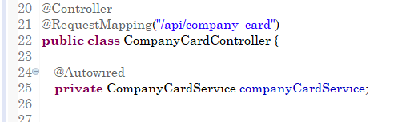

RequestMapping(“/api/company_card”) 尽量不要采用这种命名风格，不方便IDE进行全局搜索和定位。比如可以这样写：RequestMapping(“/company_card”)

对于Controller层中的方法，通常这样写：

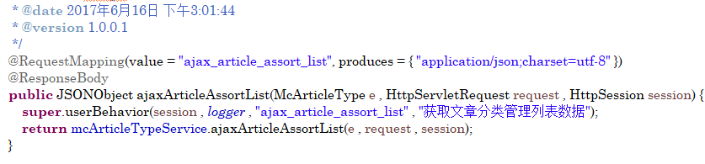

或：

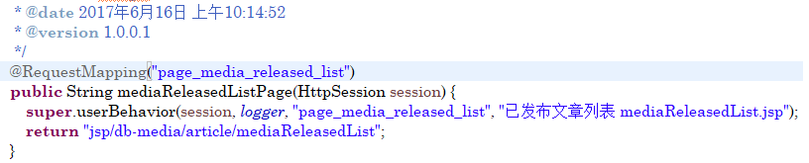

如果你写的方法是一个Ajax请求，请添加ajax_标识，如果你请求的是一个页面跳转，请添加page_标识。

下图这种写法当开发人员使用IDE全局搜索的时候，由于表意不明、不够直观，会浪费时间，不推荐。

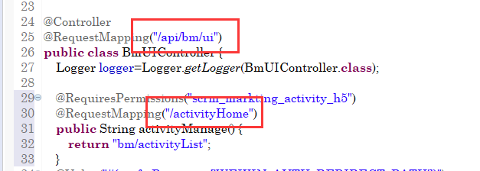

1. Controller层业务代码剥离到Service层，如下图：

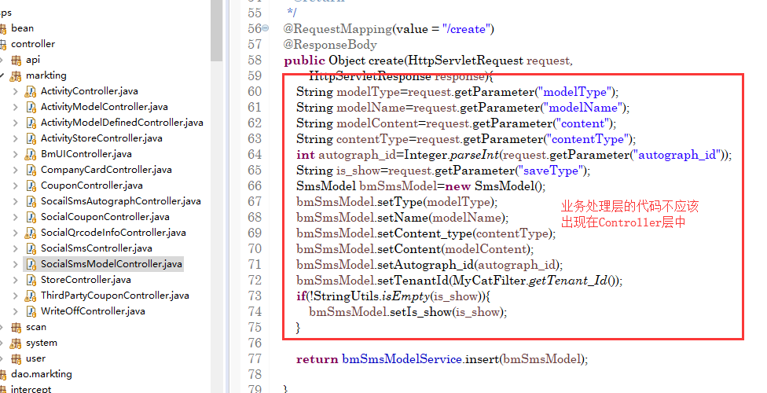

1. 代码注释 所写代码强制添加代码注释，代码样式见下图

**MyEclipse添加自定义注释**

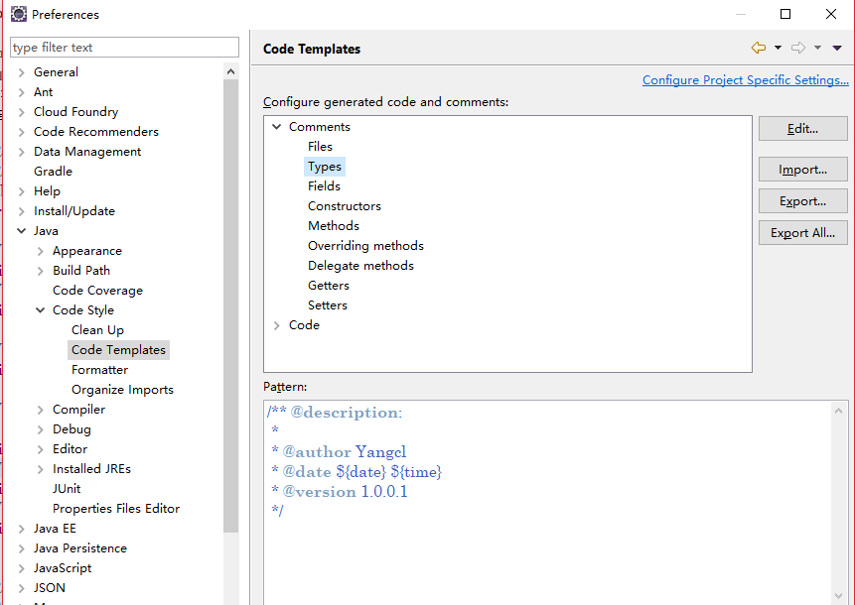

/** @description:

*

* @author Yangcl

* @date ${date} ${time}

* @version 1.0.0.1

*/

次注释对应你的类名称上的注释

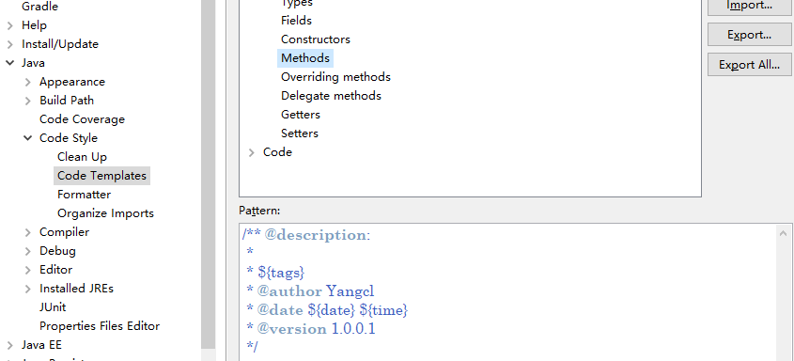

/** @description:

*

* ${tags}

* @author Yangcl

* @date ${date} ${time}

* @version 1.0.0.1

*/

次出对应你的方法上的注释

1. 去gson，使用阿里巴巴的fastjson，提升序列化效率
2. 针对SpringMvc接口类，第一个字母需要加I，比如：ISocialSmsService.java 而不是 SocialSmsService.java。需要做到表意明确。
3. 针对Dubbo的RPC接口类，需要在第六条的基础上，添加Rpc作为标识，比如：ISocialSmsRpcService.java或SocialSmsRpcServiceImpl.java。需要做到表意明确。
4. 查询时，针对多个参数的情况，需要封装成一个DTO传输模型来发送请求，而不是放置多个参数。

典型情况1：

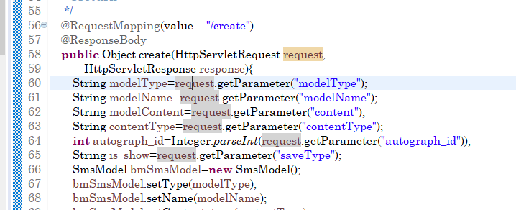

典型情况2：

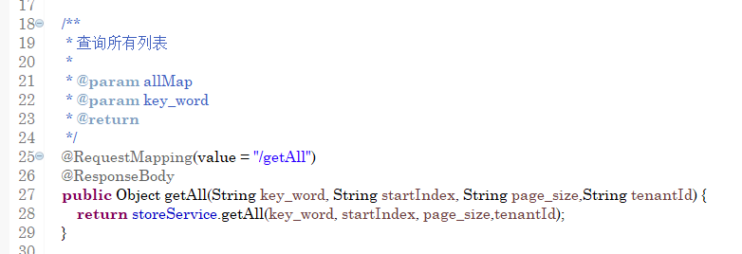

1. 所有参数、字段必须使用驼峰规则，不允许出现如上图中的String key_word这种情况